Test Project Day 4
Part 2
  - Graphic Design Technology
CN

Introduction to Test Project
试题介绍

Contents
- WSC2019_TP40_Day4_Part2.docx (this file)
- Appendix 1.0 – IWD_Logo_four_versions.ai (AI file with four versions of logo)
supplied on competitor desktop in folder called: WSC2019_TP40_Day4_CompetitorFiles
- Appendix 1.1 (Folder) - Images
supplied on competitor desktop in folder called: WSC2019_TP40_Day4_CompetitorFiles
- Appendix 1.5 – Interactive Brochure Text
supplied on competitor desktop in folder called: WSC2019_TP40_Day4_CompetitorFiles

内容
- WSC2019_TP40_Day4_Part2.docx (本文件)
- 附件 1.0 IWD_Logo_four_versions.ai (四个版本的Logo的AI 文件)
提供在选手桌面的文件夹命名为： WSC2019_TP40_Day4_CompetitorFiles
- 附件 1.1 (文件夹) – 图像
提供在选手桌面的文件夹命名为： WSC2019_TP40_Day4_CompetitorFiles
- 附件 1.5 – 交互式电子手册的文本
提供在选手桌面的文件夹命名为： WSC2019_TP40_Day4_CompetitorFiles

Introduction
International Women's Day (IWD) is celebrated on March 8 every year. It is a major event for women's rights.
IWD today ranges from being a public holiday in some countries to being largely ignored in other countries. In some places, it is a day of protest — in others, it is a day that celebrates womanhood.
Each year, IWD focuses on different important subjects related to women’s rights. In 2020, IWD will focus on empowering women through education and skills.
The main corporate colour for IWD is purple and they would like to retain their identity by having this colour as the dominant one. Additional colours may be used, but they should be warm and harmonious with the purple.
介绍
每年3月8日庆祝国际妇女节（IWD）。 这是妇女权利的重大事件。
今天IWD在一些国家是公共假期，在另一些国家很大程度被忽视。 在一些地方，这是一个抗议的日子 - 在另一些地方，这是女性庆祝的一天。
每年，IWD都会关注与女性权利相关的不同重要话题。 2020年，IWD将重点关注通过教育和技能，赋予妇女权力。
IWD的主题颜色是紫色，他们希望用这种颜色作为主色调来标识身份。 可以使用其他颜色，但它们应该是与紫色和谐、温暖配合的颜色。

Description of project and tasks
Demographics:
- Gender: Male (50%) and Female (50%)
- Age: All
- Location: International
- Income: All
- Other: This message is for all people throughout the world
Task:
- Interactive brochure

项目和任务的描述
目标人群：
•性别：男性（50％）和女性（50％）
•年龄：全部
•地点：全世界
•收入：全部
•其他：此信息适用于全世界所有人

任务：
•交互式电子手册

Instructions to the Competitor
Create a folder on your desktop called YY_TESTPROJECT_DAY4 (where YY represents the number of your workstation). All final and working files must be included in this folder.
You must include your workstation number on the presentation board and printouts for marking and delivery to your workstation (the number should be included outside of the artwork).
This folder structure will be as follows:
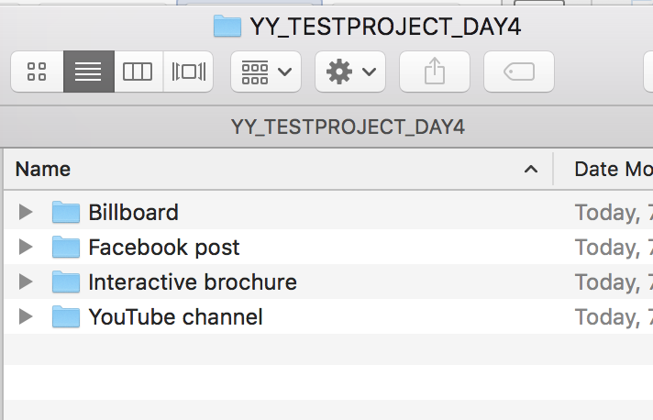

对选手的指示
在桌面上创建一个名为YY_TESTPROJECT_DAY4的文件夹（其中YY表示工位号）。 所有最终文件和工作文件必须包含在此文件夹中。
您必须在裱板上和打印稿放置工位编号，以便工作人员将打印稿送到你的工位和用以评分（工位号应包含在图稿之外）。
该文件夹结构如下：



Task 4: Interactive Brochure
You will design an 8 page interactive digital brochure that will be available on the IWD’s website. The purpose of the brochure is to showcase women of the future.
The requested interactive elements are indicated in <blue>.
Specifications
Colour and ICC Profile
- sRGB IEC61966-2.1
Size
- 8 x Single pages: 170mm wide x 170mm high
Resolution
- 150ppi

任务4：交互式手册
您要设计一个8页的交互式电子手册，将在IWD的网站上提供。 该手册的目的是向女性展示未来。
要求的交互元素以<蓝色>显示。

产品规格
颜色和ICC文件
•sRGB IEC61966-2.1

尺寸
•8 张单页：170mm宽x 170mm高

分辨率
•150ppi

Page 1 to include:
- Logo
- Text in Appendix 1.5 - Brochure Text (as per the appendix instructions)
- Additional vector or raster graphics (if desired)
- <Website clickable link (hyperlink)> https://www.internationalwomensday.com/
- <Forward button icon that goes to the next page when clicked>
Master Pages Elements
Pages 2–7 must include:
- Page numbers and footer text in Appendix 1.5 - Brochure Text (as per the appendix instructions)
- Additional graphics (if desired)
- <Website clickable link (hyperlink) to be active on pages 3–7> https://www.internationalwomensday.com/
- <Forward button icon that goes to the next page when clicked>
- <Home button icon that goes to the first page when clicked>
Page 2 — Inner Front Cover to include:
- Text in Appendix 1.5 - Brochure Text (as per the appendix instructions)

Page 3 to include:
- Text in Appendix 1.5 - Brochure Text (as per the appendix instructions)
Image: Jacqueline_1.jpg (you may edit the image)
- Additional graphics (if desired)
- <Forward button icon that goes to the next page when clicked>
- <Back button icon that goes to the previous page when clicked>
- <Home button icon that goes to the first page when clicked>
Page 4 to include:
- Text in Appendix 1.5 - Brochure Text (as per the appendix instructions)
Image: Anna_1.jpg (you may edit the image)
- Additional graphics (if desired)
- <Forward button icon that goes to the next page when clicked>
- <Back button icon that goes to the previous page when clicked>
- <Home button icon that goes to the first page when clicked>
Page 5 to include:
- Text in Appendix 1.5 - Brochure Text (as per the appendix instructions)
Image: Caroline_1.jpg (you may edit the image)
- Additional graphics (if desired)
- <Forward button icon that goes to the next page when clicked>
- <Back button icon that goes to the previous page when clicked>
- <Home button icon that goes to the first page when clicked>
Page 6 to include:
- Text in Appendix 1.5 - Brochure Text (as per the appendix instructions)
Image: Amelia_1.jpg (you may edit the image)
- Additional graphics (if desired)
- <Forward button icon that goes to the next page when clicked>
- <Back button icon that goes to the previous page when clicked>
- <Home button icon that goes to the first page when clicked>
Page 7 to include:
- Text in Appendix 1.5 - Brochure Text (as per the appendix instructions)
Image: Pearl_1.jpg (you may edit the image)
- Additional graphics (if desired)
- <Forward button icon that goes to the next page when clicked>
- <Back button icon that goes to the previous page when clicked>
- <Home button icon that goes to the first page when clicked>
Pages 8 to include:
- Text in Appendix 1.5 - Brochure Text (as per the appendix instructions)
- Logo
- Additional graphics (if desired)
- <Back button icon that goes to the previous page when clicked>
- <Home button icon that goes to the first page when clicked>

第1页包括：
•Logo
•附录1.5中的文字 - 宣传册文字（根据附录说明）
•附加矢量图形或光栅图像（如果需要）
<网站的可点击链接 (超链接)> https://www.internationalwomensday.com/
•<翻向下一页的按钮，当点击时可以跳转到下一页>

母版页元素
第2-7页必须包括：
•附录1.5 - 手册文本中的页码和页脚文本（根据附录说明）
•添加图形（如果需要）
•<网站的可点击链接（超链接），要在第3-7页上应用> https://www.internationalwomensday.com/
•<翻向下一页的按钮，当点击时可以跳转到下一页>
•<HOME按钮图标，单击时转到第一页>

第2页 - 内封面包括：
附录1.5中的文字 - 宣传册文字（根据附录说明）

第3页包括：
•附录1.5中的文字 - 宣传册文字（根据附录说明）
图像：Jacqueline_1.jpg（你可以编辑图片）
•附加图形（如果需要）
•<翻向下一页的按钮，当点击时可以跳转到下一页>
•<往回翻到上一页的按钮，当点击时可以跳转到上一页>
•<HOME按钮图标，单击时转到第一页>

第4页包括：
•附录1.5中的文字 - 宣传册文字（根据附录说明）
图像：Anna_1.jpg（你可以编辑图片）
•附加图形（如果需要）
•<翻向下一页的按钮，当点击时可以跳转到下一页>
•<往回翻到上一页的按钮，当点击时可以跳转到上一页>
•<HOME按钮图标，单击时转到第一页>

第5页包括：
•附录1.5中的文字 - 宣传册文字（根据附录说明）
图像：Caroline_1.jpg（你可以编辑图片）
•附加图形（如果需要）
•<翻向下一页的按钮，当点击时可以跳转到下一页>
•<往回翻到上一页的按钮，当点击时可以跳转到上一页>
•<HOME按钮图标，单击时转到第一页>

第6页包括：
•附录1.5中的文字 - 宣传册文字（根据附录说明）
图像：Amelia_1.jpg（你可以编辑图片）
•附加图形（如果需要）
•<翻向下一页的按钮，当点击时可以跳转到下一页>
•<往回翻到上一页的按钮，当点击时可以跳转到上一页>
•<HOME按钮图标，单击时转到第一页>

第7页包括：
•附录1.5中的文字 - 宣传册文字（根据附录说明）
图像：Pearl_1.jpg（你可以编辑图片）
•附加图形（如果需要）
•<翻向下一页的按钮，当点击时可以跳转到下一页>
•<往回翻到上一页的按钮，当点击时可以跳转到上一页>
•<HOME按钮图标，单击时转到第一页>

第8页包括：
•附录1.5中的文字 - 宣传册文字（根据附录说明）
•Logo
•附加图形（如果需要）
•<往回翻到上一页的按钮，当点击时可以跳转到上一页>
•<HOME按钮图标，单击时转到第一页>

File Types:
- Working File: InDesign
- Vector Image (links): AI, EPS,
- Raster Image (links): JPEG, PNG
- Final File: PDF/X-4:2008
Naming:
Note: YY represents your competitor number
Folder name: Brochure
- Brochure file name: YY_IWD_Brochure.indd
- Brochure file name: YY_IWD_Brochure.pdf

文件类型：
- 工作文件：InDesign
- 矢量图形（链接）：AI，EPS，
- 光栅图像（链接）：JPEG，PNG
- 最终文件：PDF / X-4：2008
命名：
注意：YY代表您的工位号
文件夹名称：Brochure
•手册源文件名：YY_IWD_Brochure.indd
•手册文件名：YY_IWD_Brochure.pdf

You must deliver
Printout
- Colour with each page centred on A4. Trimmed to 100% (actual size).
- 1 x colour A3 printout as per sample below
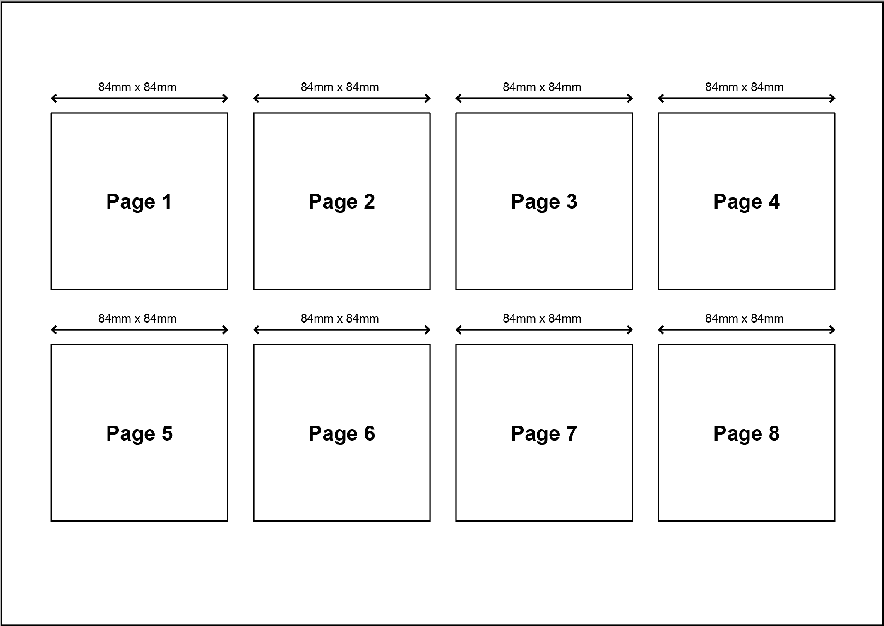

Files
- 1 x InDesign File
- 1 x PDF file
- You must include a packaged Adobe InDesign folder for submission that includes all links and fonts used.
- You must include any working files in a separate folder called: Working files

Marking Summary
The Marking Summary will be provided during the briefing session or to your workstation on C4.

你必须交付
打印稿
•八页中的每一页分别彩色打印在A4的中心位置。 100％裁切（实际尺寸）。
•如下图所示排版，打印1 页彩色A3 的作品展示


文件：
•1个InDesign文件
•1个PDF文件
•您必须包含用于提交的打包的Adobe InDesign文件夹，其中包括所使用的所有链接和字体。
•您必须将任何工作过程中的文件包含在名为“Working files”的单独文件夹中

评分摘要
评分摘要将在简报会期间提供，或在C4提供到工位。

Appendix 1.5 — Brochure Text
Note: Text to be included in brochure is Blue in colour
The black text is not to be included (they are instructions)
Page 1
Women of the Future
International Women’s Day
March 8
Raise awareness against bias
Take action for equality
Master Page
- page number
- footer:
Women of the Future
www.internationalwomensday.com
Page 2
International Women's Day is powered by the collective efforts of all
Collective action and shared ownership for driving gender parity is what makes International Women's Day successful. So make International Women's Day your day and do what you can to truly make a positive difference for women.
A balanced world is a better world.
Celebrate women's achievement.
Page 3
When young women are empowered to create opportunities for ourselves, we can design the future world we want to live in. That’s what I believe in, that’s the reason I am part of this movement.
Jacqueline Tanzer
Page 4
I am a global citizen who cares about world’s problems and who dares to look for solutions.
Anna Prokopenya
Page 5
I want girls and young women to feel empowered by the fact that they can do anything. Will you help me create a world where we allow them to dream just as big as I did, with only the sky as the limit?
Caroline Söderqvist
Page 6
I have learnt to communicate effectively to large groups, one on one and through social media, as well as develop confidence and team working skills. I have a message and a purpose which flows into all areas of my life.
Amelia Addis
Page 7
I believe we are the leaders of today. We are brave, fearless, and energetic, we are full of energy, hope, and imagination to create innovative ideas that can shape a better world.
Pearl So
Page 8
For more inspiring stories and all the latest updates, visit: www.internationalwomensday.com

附录1.5 - 手册文本
注意：手册中包含的文字为蓝色
黑色文字不包括在内（它们只是说明）

第1页
未来的女性
国际妇女节
3月8日
提高反对偏见的意识
为平等来行动
母版页
•页码
•页脚：
未来的女性
www.internationalwomensday.com

第2页
国际妇女节由所有人集体努力来推动
促进性别平等的集体行动是国际妇女节取得成功的原因。因此，让国际妇女节成为您的节日，尽你所能，真正推动女性获得积极的变革。
一个平衡的世界是一个更美好的世界。
庆祝女性取得的成就。
第3页
当年轻女性有权为自己创造机会时，我们可以设计出我们想要的未来生活。这就是我所信仰的，这就是我参与这一运动的原因。
Jacqueline Tanzer
第4页
我是一个全球公民，关心世界的问题，敢于寻找解决方案。
Anna Prokopenya
第5页
我希望女孩和年轻女性能够获得权力，做任何想做的事情。你能否帮助我创造这样一个世界，让他们拥有和我一样大的梦想，只有天空是我们的尽头？
Caroline Söderqvist
第6页
我学会了有效地与大型团体进行沟通，一对一，通过社交媒体，以及培养自信和团队合作的能力。我有一条信念，一个目标，它们融入了我的各项生活。
Amelia Addis
第7页
我确信我们是今天的领导者。我们勇敢，无所畏惧，精力充沛，我们充满活力，希望和想象力，能够创造出创新理念，来塑造更美好世界的。
Pearl So
第8页
要了解更多鼓舞人心的故事和所有最新的更新信息，请访问：www.internationalwomensday.com

